**Dog Breed Classification Using CNN**

## Project Overview

Being a Data Scientist, Deep Learning is one of the must-to-have knowledge and skills. This project is for the Udacity Data Scientist program to develop an algorithm and create a CNN (Convolutional Neural Networks) with the two tasks as:

1. Detect the object on a provided image as a dog, a human, or neither.
2. If the object was detected as a dog, based on the given classes of the world-wide dog breeds, the model would be able to identify the dog breed.

**Why Convolutional Neural Networks model?**

CNN is one of the most Artificial Neural Networks as [regularized](https://en.wikipedia.org/wiki/Regularization_(mathematics)" \o "Regularization (mathematics)) versions of MLP ([Multilayer Perceptrons](https://en.wikipedia.org/wiki/Multilayer_perceptron" \o "Multilayer perceptron)). So, A standard CNN is comprised of convolutional layers, sampling layers and then followed by fully connected layers (i.e. each neuron in one layer is connected to all neurons in the next layer).

CNN uses relatively little pre-processing compared to other [image classification algorithms](https://en.wikipedia.org/wiki/Image_classification" \o "Image classification). It takes advantage of the hierarchical pattern in data and assembles more complex patterns using smaller and simpler patterns. With the help of CNN, we can use the large amount of data more effectively and accurately.

Therefore, CNN is typically applied for Image Classification from an input image with a single object and to an output as a class label from a list of object categories.

There are a few packages available o build the CNN model such as PyTorch, Keras, etc. In this project, we use Keras library for dog breed identification.

(<https://keras.io/getting-started/sequential-model-guide/>)

## Metric

In the project, we split the input data set into training, validation and testing. The accuracy of the testing data set is used to measure the performance of the built CNN models.

## Library Preparation

The following package/library will be used in this project for data loading, data processing, data/image visualization, model development, etc.

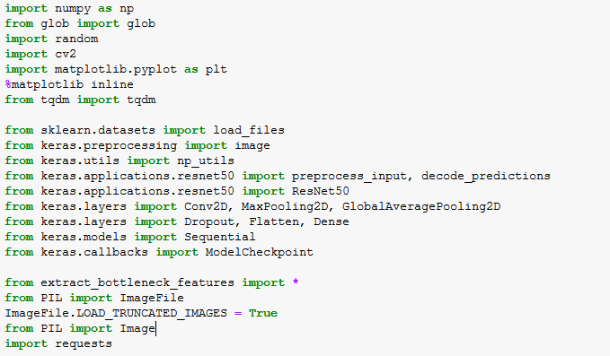

## Project Process

In addition to the dog classification, we also introduce the function to identify human face to see if the image is on a human, which is not from CNN .

Below is the flow to build the model.

*Step 0: Import Datasets*

*Step 1: Detect Human*

*Step 2: Detect Dogs*

*Step 3: Create a CNN to Classify Dog Breeds (from Scratch)*

*Step 4: Use a CNN to Classify Dog Breeds (using Transfer Learning)*

*Step 5: Create a CNN to Classify Dog Breeds (using Transfer Learning)*

*Step 6: Write your own Algorithm*

*Step 7: Test your own Algorithm*

### *In the following section, the details of the project process will be explained step by step. All the corresponding codes can be found in the [github depository](https://github.com/yz14689/DSNP_Capstone).*

### **Step 0: Import Datasets**

Two main data are used in this project: dog image and human image.

1. Dog image

The datasets were loaded via a pre-defined loading function. Three set of datasets, training, validation and testing data, are set set a ratio of 80%, 10%, 10% of total, respectively. Each set have a file of dog image and another target data with encoded dog classifications.

With the data, we have total 8,351 doc images and 133 dog categories (from dog_names) which will be used in final classification.

* *train_files, valid_files, test_files* - numpy arrays containing file paths to images
* *train_targets, valid_targets, test_targets* - numpy arrays containing onehot-encoded classification labels
* *dog_names* - list of string-valued dog breed names for translating labels

1. Another data set of total 13,233 human images were imported and used for human face detector.

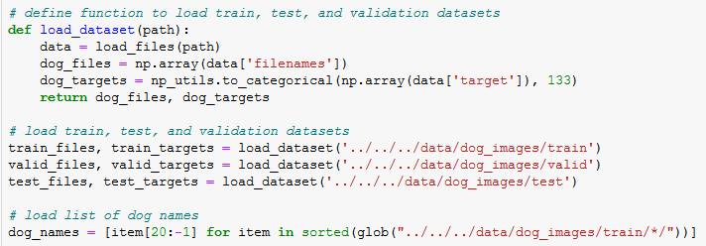



1. Additionally, there might be some other data needed to complete this project, if not available, including the bottleneck features and the sample image for final testing. The following codes will help download the files and save for next steps in the project.





### **Step 1: Detect Human**

In this step, OpenCV's implementation of [Haar feature-based cascade classifiers](http://docs.opencv.org/trunk/d7/d8b/tutorial_py_face_detection.html" \t "http://localhost:8888/notebooks/Desktop/Yan/OnlineCourse/Udacity/DataScientistNarodegree/Projects/Project_6_Capstone/MyProject/DogBreed/_blank) is used to detect human faces from images. OpenCV provides many pre-trained face detectors, while we have downloaded one of these detectors for this project, “*Haarcascade_frontalface_alt.xml”*.



Before using any of the face detectors, the standard procedure is to convert the images to grayscale. The detectMultiScale function executes the saved classifier/detector and takes the grayscale image as a parameter.

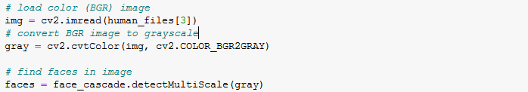

After it, an array, faces, will be created with four entries, which specify various positions of the bounding box of the detected face. Using such an array, we can develop a face detector which takes a string-valued file path to an image as input and appears in the code below.

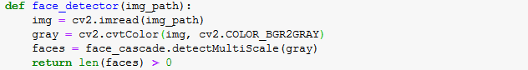

The result of using this face detector for a given image is as below:

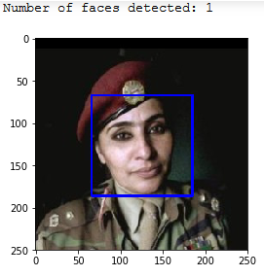

This detector was tested on 100 images of dog and human each, and we received 100% success in human images but only 11% in dog images. It implies that the fact detector works great for human face as it was designed for, but not for dog. 

So, what should we do to better identify dogs?

### **Step 2: Detect Dogs**

We use one of the most popular pre-trained model, ResNet-50, to detect dog from the images. ResNet-50 was pre-trained with more than 10 million images with 1000 categories.



Given that TensorFlow is used as backend, Keras CNNs require a 4D array (a.k.a.”4D tensor”) as input, while each dimension presents the number of rows, columns, and channels for each image.

A pre-defined function, path_to_tensor, receives the file path of a color image as input and returns a 4D tensor suitable for Keras CNN. The function first loads the image and resizes it to a square image at 224×224 pixels, and then convert the image to an array, which is then resized to a 4D tensor. In this case, the color images have three channels like (224,224,3) presenting the colors. This function takes a numpy array of string-valued image paths as input and returns a 4D tensor with shape (nb_samples,224,224,3), while nb_samples presents the number of images.

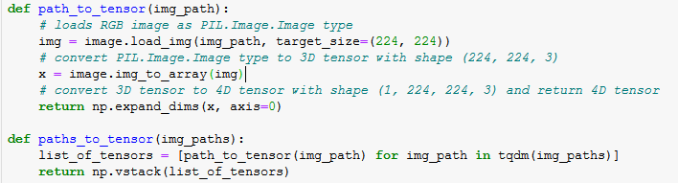

In order to use ResNet-50, additional processing, such as converting RGB to RBG image and Normalization, is required as well. Normalization is to subtract the mean pixel calculated from all pixels in all images from every pixel in each image. It is implemented with the imported function, *preprocess_input*.

With this step done, we can start using ResNet-50 to detect dogs on the image.

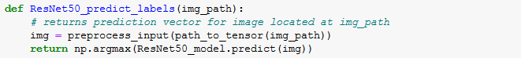

From the predicted probability vector for ResNet50, we obtain an integer corresponding to the projected object class, which is used to identify the category from a predefined [dictionary](https://gist.github.com/yrevar/942d3a0ac09ec9e5eb3a" \t "http://localhost:8888/notebooks/Desktop/Yan/OnlineCourse/Udacity/DataScientistNarodegree/Projects/Project_6_Capstone/MyProject/DogBreed/_blank). It is noticed that the categories corresponding to dogs appear in an uninterrupted sequence and correspond to dictionary keys 151-268. Therefore, checking if the ResNet50_predict_labels function returns a value between 151 and 268 (inclusive) will give us if the image is detected with a dog.

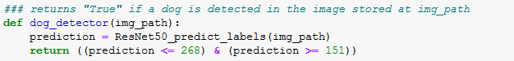

With this dog detector tested over the same set of 100 human images and 100 dog images, we have the dog images 100% identified correctly, but nothing for human images.



Now, we have the functions to identify the dog from the image.

Next, we will develop a method to classify the dog breed if a dog was detected on the image.

### **Step 3: Create a CNN to Classify Dog Breeds (from Scratch)**

Not surprisingly speaking, assigning breed to dogs from images is exceptionally challenging. Many breeds look very alike or similar, and on the other hand, some dogs with same breed but different colors may look apart. Given that only 133 dog categories were provided, we would expect the accuracy at approximate 1%.

**Pre-Process Data**

Again, before developing the CNN model, we need to process the data to make it better fit the CNN. We will re-scale the image by dividing each pixel in each image by 255. Why?

For most image data, the pixel values are integers with values between 0 and 255. It is known that Neural networks process inputs using small weight values, and inputs with large integer values can slow down the learning process. Therefore, it is good to normalize the pixel values into values in the range 0-1 and then images can be viewed normally. So, dividing the pixel by 255 will return value from 0 to 1.

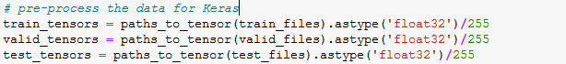

**Build the model architecture with mix of layers**

CNN as [regularized](https://en.wikipedia.org/wiki/Regularization_(mathematics)" \o "Regularization (mathematics)) versions of [Multilayer Perceptrons](https://en.wikipedia.org/wiki/Multilayer_perceptron" \o "Multilayer perceptron) is comprised of convolution layer, pooling layer, dense layer, etc.

In this architecture, we enhanced the CNN model from the structure provided by the program, by adding some other layer in order to develop the lower loss and better accuracy.

I tested a few different layers in the model.

Test model #1, replace GlobalAveragePooling layer with Flatten(): It broke the spatial structure, required much high parameters and then was very time consuming, but produced much higher loss and lower accuracy.

Test model #2, add Dense layer with activation of ‘relu’ in the first three sets of convolution and max pooling layer and adjust the array dimension to >300: It connected the front layers and flatten it. The earlier Dense layer did not help improve model.

Test model #3, add BatchNormorlization: It helped a little on loss improvement, but very time consuming. Comparing to other more effective improvement, it is not implemented in the model for this project.

The final model architecture is based on the three set of convolution and max pooling layers but add two Dropout layer to reduce the possible overfitting and add one more Dense layer after GAP layer to connect all neurons.

The final Dense layer as full connected layer is acting as classifier with 133 nodes to identify the dog breed based on the provided 133 categories.

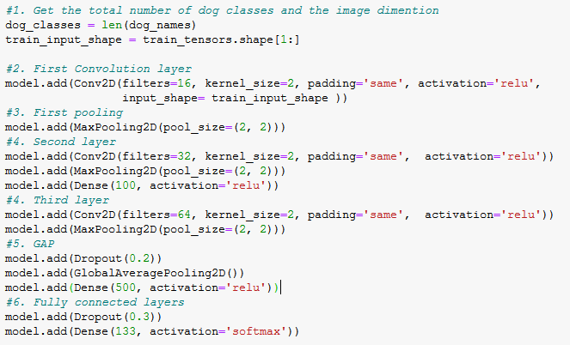

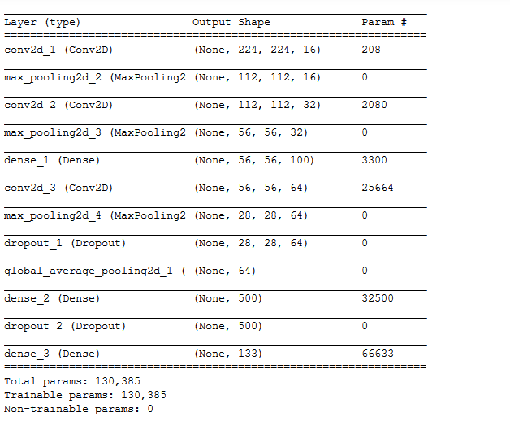

The total trainable parameters or weights for this model is 130K.

The model was compiled with the optimizer ‘RMSprop’, which divides the learning rate by an exponentially decaying average of squared gradients. It also uses the loss function of ‘categorical_crossentropy’.



The model was trained with 10 epochs. I also tested training the model with 5 epochs, which presents lower accuracy and higher loss.

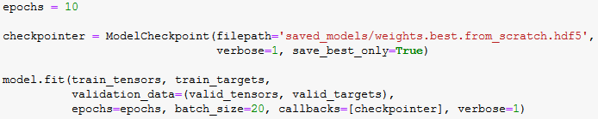

After loading with best validation loss, the model was tested over the testing data and returned **5.5%** accuracy without any fine-tuning of parameters and without any augmentation on the data.

### **Step 4: Use a CNN to Classify Dog Breeds**

During the prior model architecture development, the long model training was top concern. To reduce the training time but still maintain the performance, a popular approach in deep learning, Transfer learning, was introduced.

Transfer learning involves taking a pre-trained neural network developed for a task and adapting the neural network to a new data set as the starting point for a model on a second task. Having this, the second model will utilize knowledge from the learned task and be more efficient without repeating the training.

The last activation feature map in the VGG16 model gives us the bottleneck features, which can then be fed to our model for a classifier. The bottleneck features can be downloaded from the resource as shown in “Library Preparation” section.

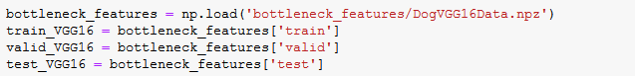

In this step, VGG-16 model was used as a fixed feature extractor and the last convolutional output will be fed as input to our CNN model for dog breed identification. Only one GAP layer and a fully connected layer (with softmax) were added as classifier.

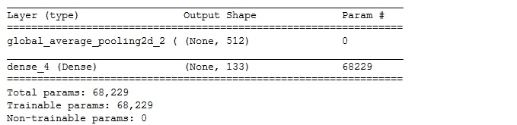

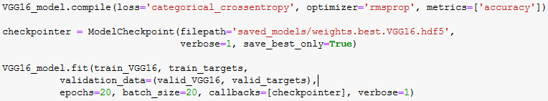

The test accuracy of the model above was **47.6%**, which was much improved from the CNN built from scratch in last step.

### **Step 5: Create a CNN to Classify Dog Breeds (using Transfer Learning)**

In this step, similar as how the VGG16 model was used, I will apply Transfer Learning to create a CNN using another pre-trained model available in Keras, InceptionV3.

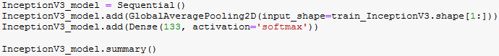

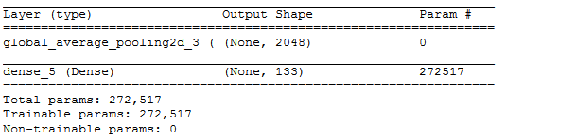

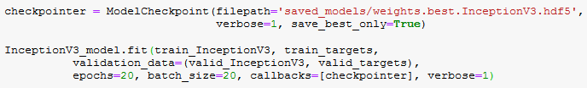

After compiling the model and loading with the best Validation loss, we test the model on the test data of dog images and received the target accuracy of **78.3%**, much higher than the targeted of 60% from Udacity .

A predictor is created for next step.

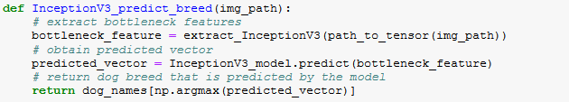

### **Step 6 & 7: Write and Test your own Algorithm**

In this step, I will develop an algorithm that accepts the path of the image.

The first task is to determine if the given image contains a dog, or a human, or neither.

The next task is

* if a **dog** is detected in the image, return the predicted breed, using the predictor created from last step.
* if a **human** is detected in the image, return the resembling dog breed.
* if **neither** is detected in the image, provide output that indicates an error.

The function of classifier is built as below.

First of all, an image as input will be loaded, and then the downloaded bottleneck features for the selected pre-trained model will be applied to the image, this is then processed through our trained fully-connected model to give a prediction vector.

To this we apply the numpy argmax function to extract the highest probability class/index and use our labels right from the beginning of the notebook to get the name of the dog breed.

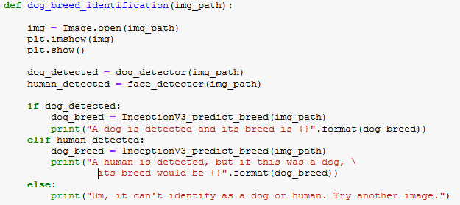

Next, I will test the defined algorithm on various images, including samples selected from internet. How is the model?

### **Model Results and Refinement**

Given that 78% of test accuracy, the model was not as good as expected. Actually, based on the result testing on the images I had, the model was able to differentiate dogs, human and non-dog objects excellently, but when classified the dog breed, it did not work well as expected.

* Image #.1 and #.2 were correctly identified as dog and their breeds.
* However, the #.3 was a rottweiler, but was incorrectly predicted as bordueaux as the #.2.
* Image #.4 and #.7 were correctly classified.
* The rest of image including human pictures, carton neither dog nor human images were all successfully identified from dogs.
* The last image is a masked/covered human face, but the model still worked. It implied that the model was able to grasp the key feature and characters of the image.

There are a few ways to improve the model, including but not limited to the following:

* Increase the breeds and train more images
* Increase number of epoches
* Augmentation of training data
* Tune some of the model parameters

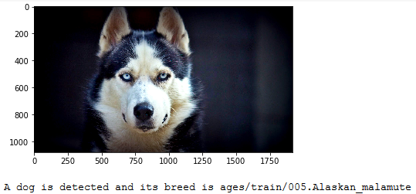

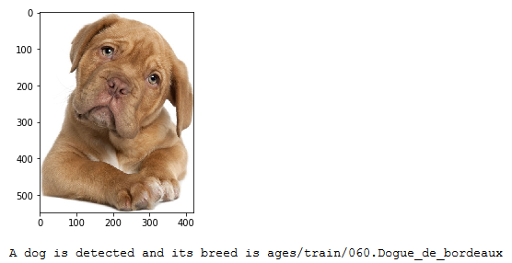

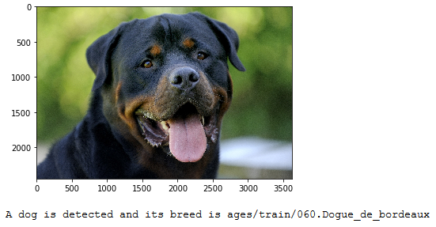

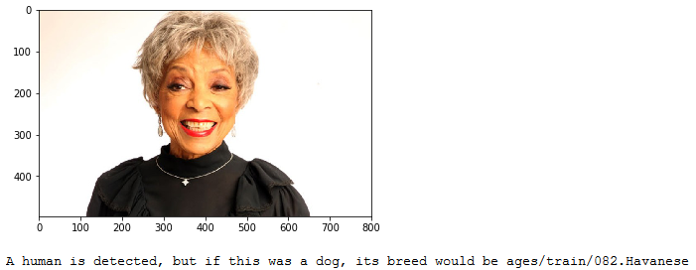

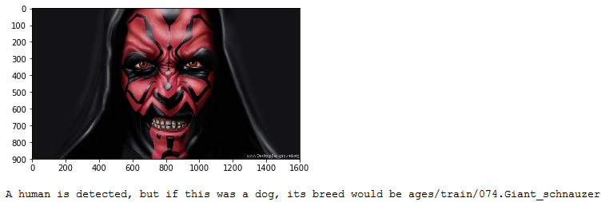

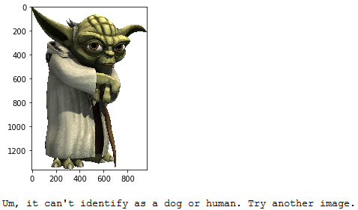

## Reflection

From the actions done through this project, it is approved that CNN is very effective and efficient for image classification, such as the dog classifier I try to develop in this project.

In this project, I learned how to build the detector to identify dog or human face from the image and subsequently identify the dog breed if applicable. The task could be done from different ways, such as by e defined detector, the CNN built from scratch and the CNN built from Transfer Learning.

Compared to the pre-trained models used applied in the process, such as VGG16 and InceptionV3, my own CNN architecture does not work so well. It is approved that the more images the model was trained and the more categories to classify to, the more the model is learning and the better the model predicts.

There are also some items I will test on the CNN model in future to improve the performance, including:

1. Train more images, especially more clear images.
2. Optimizer, loss function and other augments used in model compiling
3. Expand the size of dog breed classifications

## Refer**ence:**

1. <https://en.wikipedia.org/wiki/Convolutional_neural_network>
2. <http://deeplearning.net/tutorial/lenet.html>
3. <http://deeplearning.stanford.edu/tutorial/supervised/ConvolutionalNeuralNetwork/>